**Define problem statement Customer Problem Statement Template:** Create a problem statement to understand your customer's point of view. The Customer Problem Statement template helps you focus on what matters to create experiences people will love. A well-articulated customer problem statement allows you and your team to find the ideal solution for the challenges your customers face. Throughout the process, you’ll also be able to empathize with your customers, which helps you better understand how they perceive your product or service.

**Solution:**

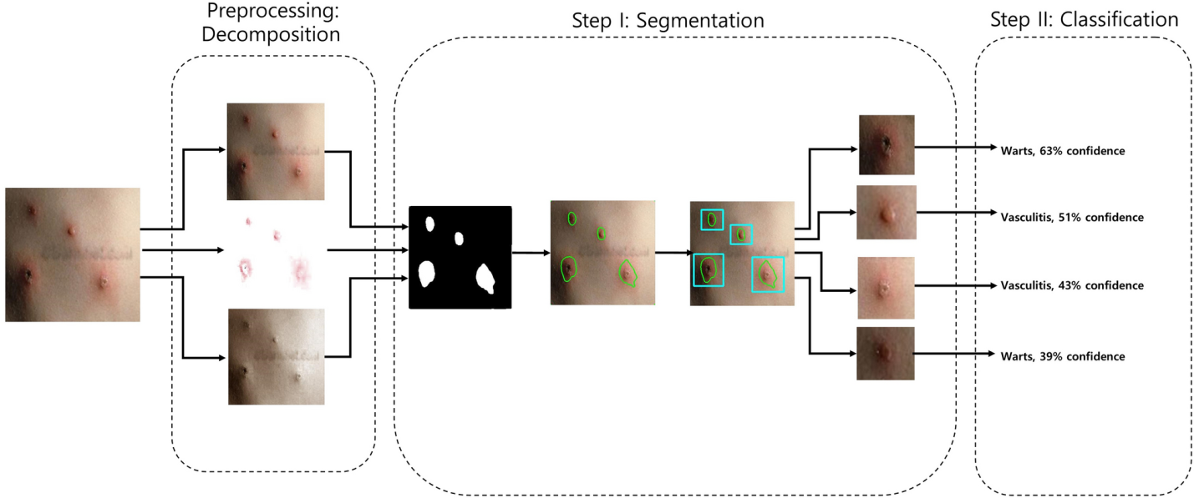

|  |  |  |  |  |  |
| --- | --- | --- | --- | --- | --- |
| Problem statement(PS) | I am (customer) | I’m trying to | But | because | Which makes me feel |
| To detect the erythema skin disease earlier as possible ,to prevent the skin cancer. | Person with skin disease. | Figure out if my disease is erythema or not. | I can’t find any website which gives accurate result. | There is no customized website to detect only erythema and so the accuracy is low. | Worried and irresolute. |
| To detect the type of skin disease using machine learning model. | Skin disease detector. | To detect the person having such disease by image. | But only detects whether having disease or not. | Because it can’t able to predict the which disease accurately. | The level of usage and need is low. |